Name: | ___________________________________________________ |  | Date: ___________
 | Year 10 Pre-Stage 2 and 3  Take Home Component  (Review factorising and Expanding)  QUADRATIC FUNCTIONS – SOLVING EQUATIONS |  | = %
Total Time: | 55 minutes | Penalties (only deducted once in the whole assessment):   Rounding - Incorrect/inappropriate (-1)   Notation – incorrect/missing (-1)   Units - Incorrect/missing (-1)
Weighting: | _0___% of the year.
Equipment: | Scientific calculator and CAS calculator
Important Information:

Important Information:
Although the take-home component is not worth any marks, it is essential in preparation for the in-class component. Knowledge and skills gained will be extended in the in-class validation component. This in-class validation will be completed under test conditions on the day in which this take-home component is due. The take-home component may be used when completing the in-class component. Contact may be made to parent(s) if the take-home component is not available for submission (at the start of the lesson).

AIM: To review factorising and expanding quadratic equations. Solving quadratic equations algebraically using Null Factor Law; graphically; using CAS.

 | NOTES
A quadratic expression in x is an expression of the form ax² + bx+ c where x is the
variable, and a, b and c are constants with a ≠0:

A quadratic equation can be in:
i) General form: y = ax² + bx + c
ii) Factor form: y = (x + a)(x + b)
iii) Turning point form: y = a(x + b)² + c

 | SOLVING EQUATIONS USING NULL FACTOR LAW
In order to understand how to factorise the quadratic equation click the following link below:
http://www.purplemath.com/modules/factquad.htm
The Null Factor Law tells you that if two numbers are multiplied and one of the numbers is 0, then the other number must be 0. eg 6 x 0 = 0
0 x 4 = 0
If you are using brackets, the either the numbers in the first bracket must add to 0 so you can have:
eg 0(x + 2) = 0
Or
the numbers in the second bracket must add to 0 so you can have:
eg (x – 4)0 = 0
Therefore: (x + 2)(x – 4) = 0
x = – 2 so that – 2 + 2 = 0 or x = 4 so that 4 – 4 = 0
 | FACTORISING QUADRATIC TRINOMIALS
1. | Factorise x² + 5x + 4 = 0
Step 1
Write down all the possible numbers that can multiply together to give the last term of the equation (x² + 5x + 4 = 0) i.e. 4 x 1 or – 4 x – 1 both multiply to give 4
2 x 2 or – 2 x – 2 both multiply to give 4

Step 2

Now, out of all the possibilities above, pick a pair of two numbers that can add or take away to give you the middle term of the equation (x² + 5x + 4 = 0) i.e. + 5

The two numbers are 4 and 1 because 4 + 1 = 5

Step 3

Write your two numbers in the spaces below in the brackets with x.

(x + ⁪) (x + ⁪) = 0
Step 4

Write the two answers for x:

x = or

2. | Factorise the following using the above method:
a) | x² + 3x + 2 = 0
b) | x² + 3x – 10 = 0
c) | 2x² + 6x + 8 = 0 (Hint: Divide the whole equation by 2)  New equation will be  Solve it
d) | x² - x – 56 = 0
 | SOLVING EQUATIONS USING THE DIFFERENCE OF SQUARES
Click the link below to understand the difference of squares:

http://www.mathsteacher.com.au/year9/ch08_factors/05_difference/twosquares.htm

3. | Solve x² – 9 = 0 using the difference of squares
Step 1:

Factorise 4x² – 9
- Draw 1 set of double brackets
- Find the square root of the 1st term and put it as the first term in each bracket
eg (2x )(2x )
- Find the square root of the 2nd term and put it as the last term in each bracket
eg (2x 3)(2x 3)
- Now make one bracket be + and one bracket be –
eg (2x + 3)(2x – 3)
- Now solve as above for values of x that make the product = 0
4. | Solve the following quadratic functions using the difference of squares.
a) | 4x² – 25 = 0
b) | 4x² – 1 = 0
c) | 9x² – 16 = 0
 | SOLVE THE EQUATIONS USING TI CAS CALCULATOR
5. | Follow the following prompts on CAS to solve the equations.
25x² – 10x + 1 = 0

Step 1
Turn the CAS calculator ON. Go to the calculator.



Step 2
On the Calculate screen either type ‘solve’ or press menu, then Algebra and then solve
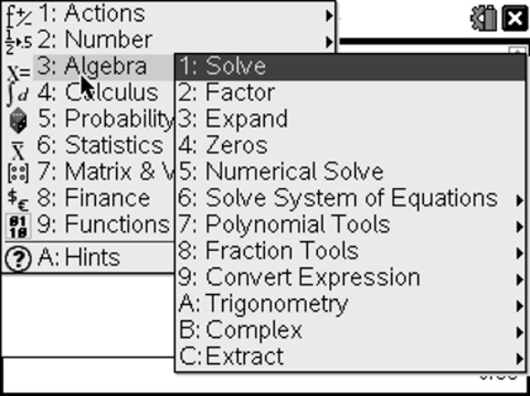
Step 3

Type the equation in your calculator as shown below:
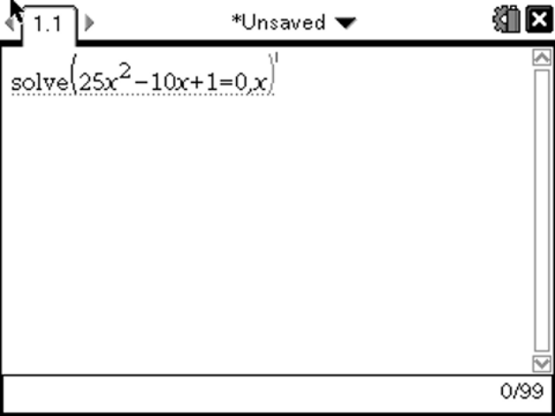

Press enter to get the desired result(s)
Answer for x = ________

 | Are there any integer values for ‘a’ for which your pattern will NOT work?
6. | Solve the following quadratic functions using CAS calculator.
a) | P² – 49 = 0  Answers:
b) | 81 – y² = 0  Answers:
c) | (x – 3) ² – 4 = 0  Answers:
d) | 2x² - x = -2  Answers:
e) | 4x² +12x + 9 =0  Answers:
f) | 3x² - 2x – 5 = 0  Answers:
 | WORDED PROBLEMS USING QUADRATICS
 | The product of two consecutive numbers is 210. Find the numbers
a) | Write the unknown quantity algebraically.
Let the first number be n and the second number be n+1
Because the consecutive numbers occur one after the other
b) | Write down the information you have been given. (You may need to draw a diagram sometimes).
c) | Write an equation from the information above.
 | n (n + 1) = 210
d) | Expand the brackets.
e) | Rearrange the terms above in a way that the whole equation becomes equal to zero (Hint: move 210 on to the other side of the equation)
f) | Factorise the above equation or set up the equation so you can use the Null Factor Law.
g) | Solve the equation for x.
h) | Write you answer in words.

----------------- End of take – home component ----------------

